**Environmental Science and Pollution Research**

**How to submit conference paper to special issue**

**Step 1:** Go to[**https://www.springer.com/journal/11356/updates/24058002**](https://www.springer.com/journal/11356/updates/24058002)

Click submission at **https://www.editorialmanager.com/espr/default.aspx.**

**Step 2:** Under the ‘Select Article Type’ dropdown, click on ‘Research or Review’

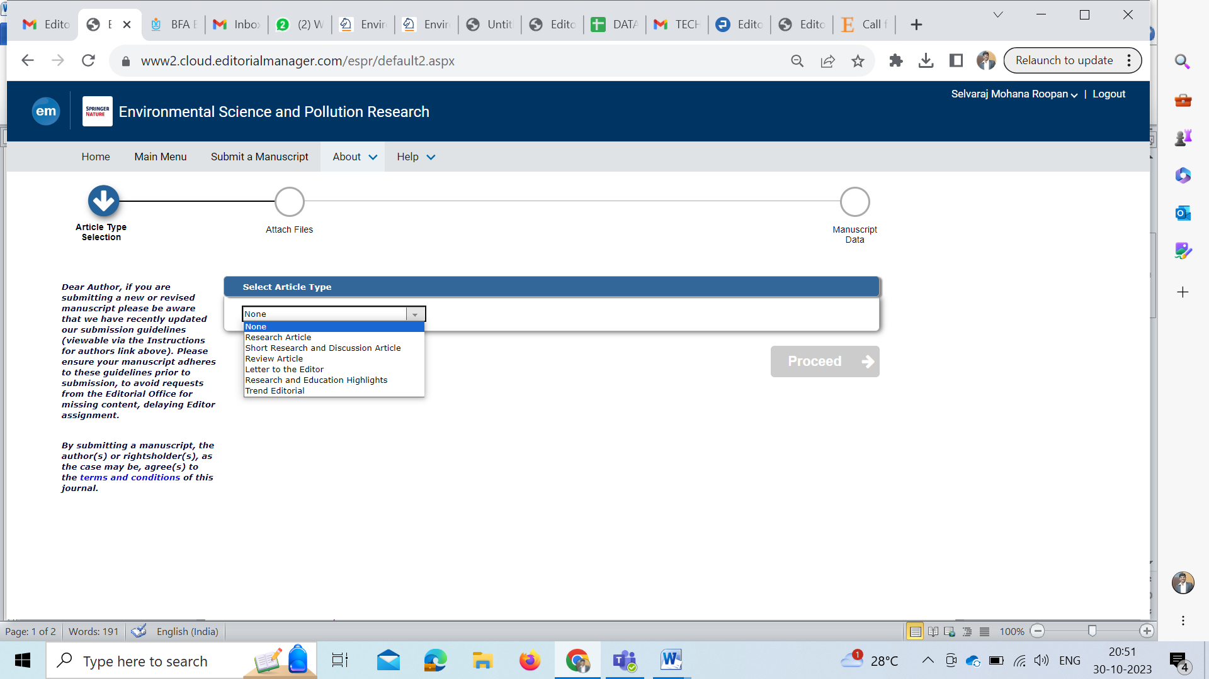

**Step 3:** Attach files: Attach all the necessary documents and click on ‘Proceed’

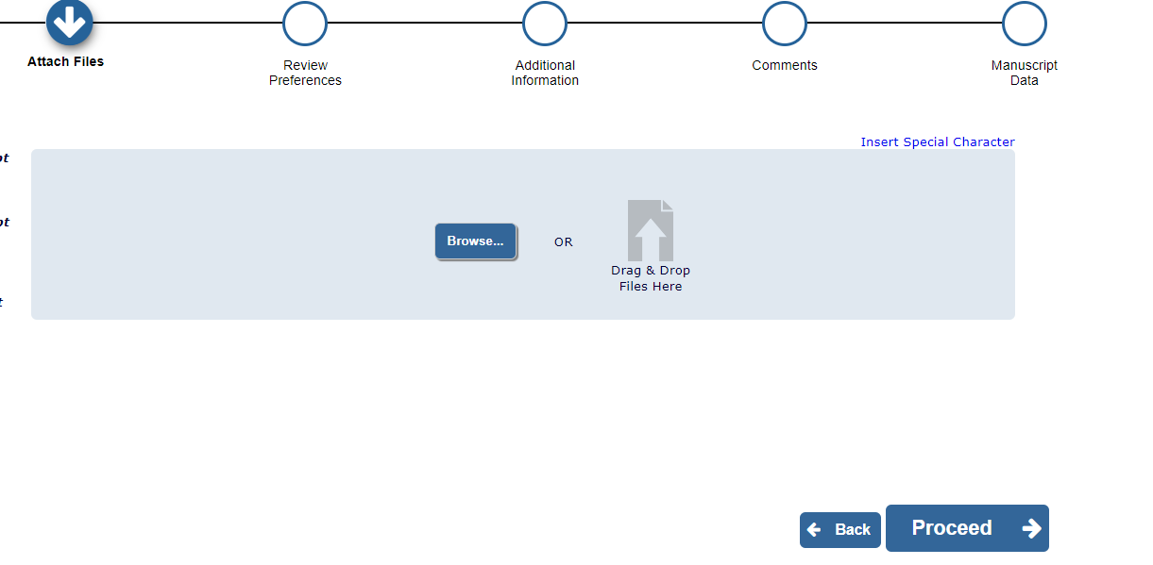

**Step 4:** Review preferences

Suggest three potential reviewers in your field of expertise (Preferably ones from other than your country). Provide specific reasons for the same in the comment box, for each of the reviewer. Please note that the editorial office may not use your suggestions, however, it may assist in speeding up the selection process of appropriate reviewers. Corresponding Author must provide an institutional email address for each of the suggested reviewer.

**Step 5:** Addition Information

Click ‘Yes’ under ‘Are you submitting to a Special Issue?’ and select **SI: SWT-TS23**

**Step 6:** Comments

Please enter any additional comments you would like to send to the publication office. These comments will not appear directly in your submission.

**Step 7:** Manuscript Data

Fill manuscript title, Abstract, Keywords, Authors and funding information

**Step 8:** Build PDF for approval